
The Trusted Name In Fitness
710 Recumbent Bike | 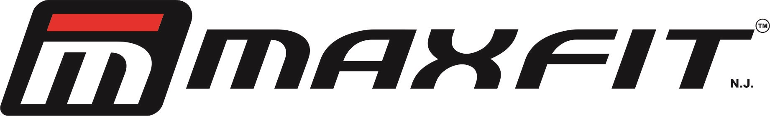
Resistance: Magnetic 8 Level Resistance Control, Flywheel 10kg
Display: Single LCD Window Display Showing Speed, Distance, Calories, Time, Pulse
Extra Comfortable Mesh Type Seat to Adapt to the natural back posture.
Transportation Wheels, Stylish Look, Maximum user weight: 110 kg
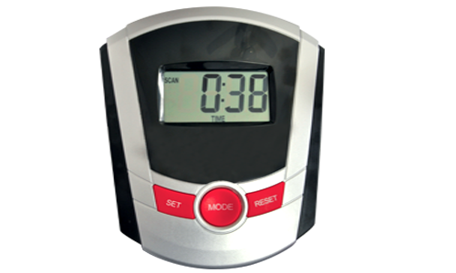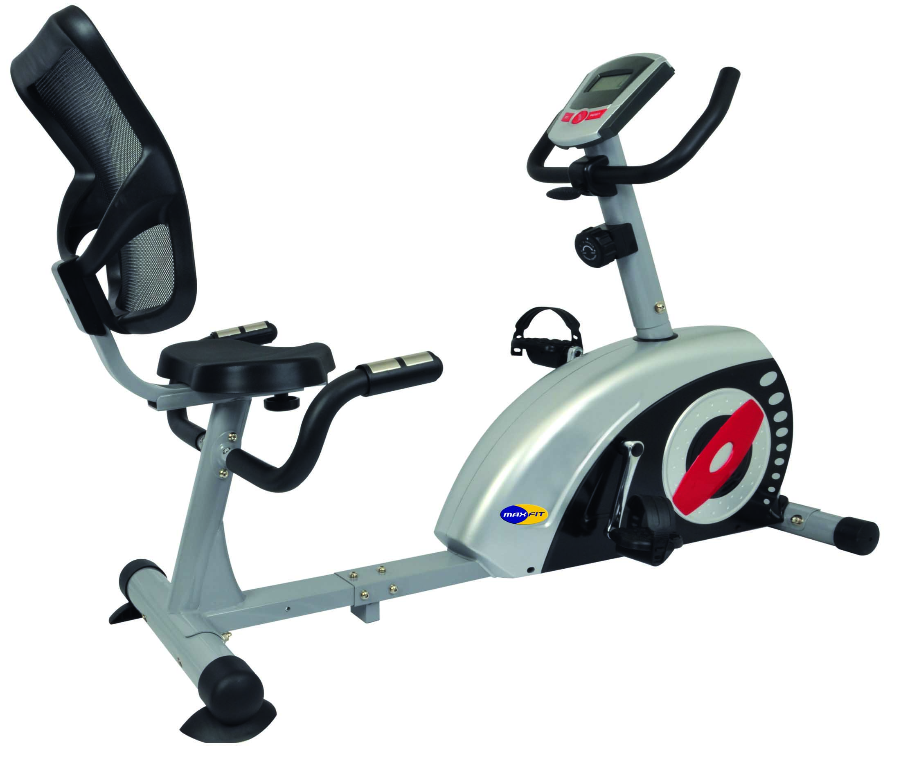 |  |     Quality Approved Products      We Encourage Printer Friendly Brochures, and we print only those brochures that you need. Go Green!
V.V. Vintage Boulevard, Raj Bhavan Road, Somajiguda, Hyderabad-500082
Ph: 040- 2341 6161, 6636 7070 Email: maxfitindia@gmail.com www.maxfitnessindia.com

